问题一：分析附件1中两组评酒员的评价结果有无显著性差异，哪一组结果更可信？

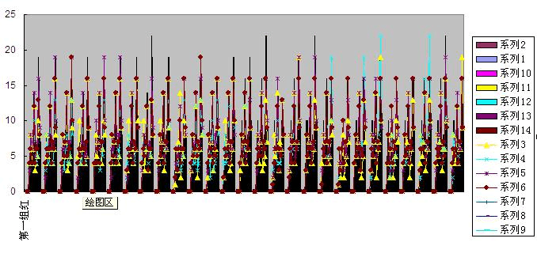

[problem1.m]哪一组结果更可信

function y=xlsread（’D\cumcm2012problems\A’）

global a10a20a30total k;

syms k a10;

x1=dsolve('Dx1=-0.75\*x1','x1(0)=a10');

t=1;a20=subs(x1);

x21=dsolve('Dx21=-(0.75+0.32\*k)\*x21','x21(0)=a20');

t=2/3;a21=subs(x21);

x22=dsolve('Dx22=-0.75\*x22','x22(2/3)=a21');

t=1;a30=subs(x22);

x31=dsolve('Dx31=-(0.75+k)\*x31','x31(0)=a30');

t=2/3;a31=subs(x31);

x32=dsolve('Dx32=-0.75\*x32','x32(2/3)=a31');

nn=1.109\*10^11\*(0.5\*a21+a31);

eq1=a10-nn\*1.22\*10^11/(1.22\*10^11+nn);

S=solve(eq1,a10);a10=S(2);

syms t;

t3=subs(subs(int(0.32\*k\*x21,t,0,2/3)));

t4=subs(subs(int(k\*a31,t,0,2/3)));

total=17.86\*t3+22.99\*t4;

k=x;

y=subs(-total);

function y=problem1(x)

global a10a20a30total;

[k,mtotal]=fminbnd('buyu',16,18);

ezplot(total,0,25)

xlabel('组别')

ylabel('系列')

title('')

format long;

k

total=-mtotal

a10=eval(a10)

a20=eval(a20)

a30=eval(a30)

format short

clear

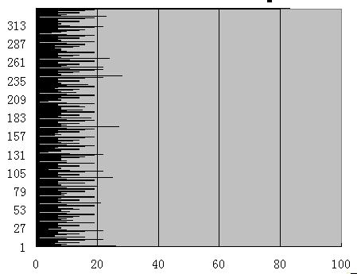

综上所述，第二组更可信。